**PRACTICAL NO:-8**

**a)Create a web application to demonstrate use of GridView button column and GridView events along with paging and sorting.**

**You can directly can start paging sorting selection through selection through below:-**

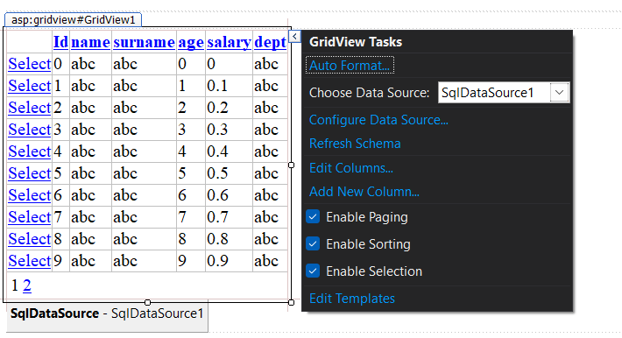

**OUTPUT:-**